CONCEPT
LAGI 2020 FLY RANCH
Supplemental Information

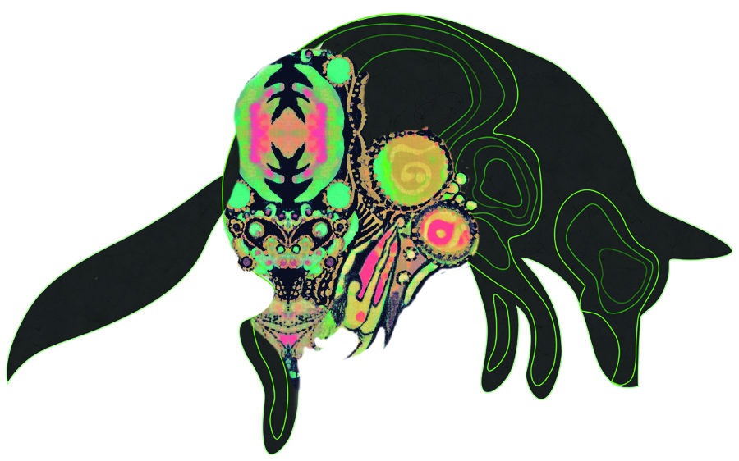
When visiting Fly Ranch, one is struck by the sweeping serenity. The site already includes several large and lovely artworks, that nonetheless manage to seem both inconsequential —and obtrusive— at the same time.
Therefore, when attempting to envision an alternative energy installation/ artwork one is forced to pause: what work of humankind could be ambitious enough to break new ground, without being incongruous or obtrusive?
Coyote Mountain is designed to visually blend into the Calico Range behind it, providing energy, laboratories, art studios, greenhouses, conference center, galleries, living quarters, and support services for future waste treatment and other projects.
Coyote Mountain is a topographic structure— a diagram of a mountain —with a polymesh skin, in a shape recognizable from low earth orbit. It is 120 ft (37 m) high, & consists of 6 stories of 20 ft each. When fully realized, it will contain 250,000 square feet (2,325m2) of climate-controlled space— the equivalent of
a small town. Materials include rammed earth, steel, Low-E glass, glue-lams, & Trex™, to resist the sun, wind, dust storms, wildfire, heat, cold & cloudbursts endemic to the Black Rock Desert.
Visitors will access the property at the middle entrance, and proceed north to the smaller central “high-use” area, where there will be a small orientation building and low-impact campground. From there, Coyote Mountain is one mile away and blends into the mountains behind it. Improved roads will take vehicles further north, and then east to the complex, which sits on the edge of the playa. Our proposal bypasses Fly Geyser completely, leaving it as is.
COYOTE MOUNTAIN

Technology
The energy needs of an average commercial building in the US are 22.5KWh/SF/year. Power plant output is stated in Megawatts per Hour. We calculated 0.642MW/hour would be needed to power Coyote Mountain.

Geothermal
For powering such a large environment off-grid, Binary Geothermal is available. Testing reveals the Hualapai playa has good thermal conductivity & a thermal gradient of about 75°C. The playa clay forms a thermal cap, keeping heat trapped fairly close to the surface. Four small Climeon™ Binary Units can provide 0.6MW/hour from relatively shallow wells and provide 5,256MWh per year. Using an off-the-shelf power plant reduces costs. The system is scalable by adding more units. Geothermal also directly provides heat & hot water to the building, further reducing energy needs and would lower needed energy by 2.5kW/SF/year. Again, this does not impact Fly Geyser at all.
Binary Cycle geothermal releases no emissions except water vapor. Binary cycle plants extract sub-boiling water, pipe it through a heat exchanger, heating a secondary liquid (like isobutane) that boils at a lower temperature than water. The hot water is then piped back underground, while the boiling isobutane runs a generator.

Solar
Coyote Mountains’ polymesh skin consists of equilateral triangles of ClearVue™ Luminescent Solar Concentrators, (a transparent solar panel) mixed with conventional Low-E glass. Triple-glazed ClearVue LSC glass admits visible light, but reflects infrared/heat. They currently collect 30w/m2 of solar energy, and do not need to face the sun to be effective; calculations specific to insolation in Hualapai are below for a hypothetical 100 meter cube. We used an average of 2,725. We can vary the number of panels based on need, up to a maximum of approximately 12,500m2, yielding 340MWh/year or .04Mw/hour.
Orientation | SQM | Power | W | KW | kWh/Year
N | 100 | 30 | 3000 | 3 | 1050
S | 100 | 30 | 3000 | 3 | 3283
E | 100 | 30 | 3000 | 3 | 2659
W | 100 | 30 | 3000 | 3 | 2556
Roof (Flat) | 100 | 30 | 3000 | 3 | 4091
 | 500 |  |  |  | 13639
With the addition of electrochromic switchable glass coatings and existing software, an interconnected HVAC system can respond by itself to environmental needs inside the building, reducing energy costs.

Wind
The ground floor is bisected by an open return wind tunnel that gathers and channels the prevailing winds, accelerating them above 3 m/s: the “cut in” speed for turbines. Wind power is cubed: when you increase the wind speed from 1.5 m/s to 3 m/s, the result is 8x the power. Inside the wind tunnel, is a forest of beautifully ornamented Vortex Tacoma™ bladeless turbines. Each turbine generates up to 100 Watts of power. There is room for as many as 288 turbines in the tunnel for a maximum of 28,800 watts, but average wind speeds will probably yield less: about .014MW/hour.

Power Grid
A Tesla Powerpack Microgrid can store this power and connect to our private grid. It is also scalable, to serve Black Rock Station and, in conjunction with temporary power lines, can provide Zero Carbon electricity to Black Rock City once a year.

Interior & Uses
Inside the complex, a climate-controlled environment will contain artist studios, research laboratories, greenhouses, parks and gardens, a conference center, galleries, library, cafe, gym & simple living quarters. Bright lofty spaces full of shade and desert sun will alternate with cozy interior spaces. Mezzanines will divide some portions into 10 foot high living and learning areas, further increasing usable square feet

WATER management
Periodic desert cloudbursts will result in large volumes of water coming off the structure, so drains must be properly designed, and the water collected for re-use in the interior greenhouses.

Zoning
Coyote Mountain is a quasi-public building complex, containing a visitors center, galleries, conference center and library. Washoe County’s General Rural height restrictions should therefore not apply.

materials
A conventional steel frame will support and supplement less common materials; curved rammed-earth walls in warm layers of color will be created from local clays. Rammed earth— a high-labor, low-skill process, also lends itself to community involvement in the building process; a venerable Burning Man tradition. Low-E glass will supplement the ClearVue™ LSC panels. “Wood” will come from the local Trex™ factory in Fernley, NV, turning used plastic shopping bags into desert-resistant cladding, decking, and details. Concrete will be minimized.

Inputs & Maintenance
The complex is off-grid, generating its own power and using it’s water rights and wells. The activities inside will require changing inputs. In years of little rain, power washing of the glass skin solar panels may be needed. Basic building and HVAC maintenance should suffice.

Conceptual cost estimate
A project of this size has numerous inputs that can be altered to change the final cost. Using the 2019 average cost of constructing a commercial building in the US, malls average $100/SF, while more customized and highly equipped restaurants average $200/SF. Our proposed complex is not that structurally unusual except for the curved exterior walls and polymesh skin, so we will guesstimate a middle ground of $150/SF or $37 million. If the polymesh skin is 100% ClearVue glass, add approximately $5 million.

Rangeland restoration and Biosolids
At this time in the regulatory scheme, it is not practical to process all the biosolids produced by Burning Man, Black Rock Station and Fly Ranch on site. But we would propose fencing the no-impact areas and obtaining biosolids from the nearest facility for rangeland restoration. Biosolids have been found to be superior to chemical fertilizers for this purpose. We would love to see native bunch grasses blowing in the wind again, untrammeled by cattle or wild horses. Cattle can be grazed on the large low-impact parcel in the northwest area in order to maintain county agricultural use benefits.

SPACEPORT & TRANQUIL HARBOR PROJECT
Our proposal extends into the future. We propose to lift a Burning Man sculpture off the playa within a few years, using space-warp technology! Currently, this technology can lift .5 pounds with 800w of power, using fractal antennas to expand space on one side of an object, while contracting space on the other side. An NSF grant is in the works. If development proceeds apace, lifting payloads to orbit will provide a safe, relatively low-impact, emission and propulsion-free revenue stream for Fly Ranch. The parcel near Gerlach and its rail siding would be ideal.

PROTOTYPE
We propose to construct a sculpture with a sheltered space inside, using rammed earth, elaborately tinted ClearVue™ LSC solar glass, tensile textiles, stainless steel and a portable Tesla micro-grid to power the electronics. Light and ambient music will be overlaid with the disembodied voices of artists discussing creative collaboration. The piece will incorporate messages concerning the marriage of science and art.
With a budget of $15,000 US, we would allocate about half to ClearVue™ panels, (at $400/sm) and the rest to conventional glass, steel & fabric. The portable micro-grid will not impact the budget— it already exists. ClearVue Technologies in Australia is standing by to help us prototype.
-end-
1460 words

Supplement: Environmental impact
“Zero Emissions” is a misnomer. All works of humankind depend upon the disrupting activities of extraction (mining) or agriculture, and their attendant emissions. However, once the manufacturing of alternative energy collectors is complete, we can ride that clean wave for a long time. In essence, we propose to build a small enclosed town that produces no emissions and little waste on site.
- Rammed earth, in low-precipitation areas like Hualapai, has a lifespan of hundreds of years.
- ClearVue™ LSC have an estimated service life of 20+ years.
- Trex™ materials are guaranteed for at least 25 years in the desert sun.
- Vortex Tacoma™ turbines, with no moving parts, will have a very long service life. And unlike spinning turbines, they kill no critters.
- Binary Geothermal emits only steam, and will look similar to the steam let off by Fly Geyser.
We would not bother with LEED Certification, it is an expensive process that doesn’t measure much and would not benefit a project that is not for sale, and that functions as it’s own off-grid closed-loop ecosystem.
As time passes & humans cease to use the facility, the glass will begin to break and dust will quietly sift in. Drifts will cover the outside, and it will become… a mountain. In 6020, archeologists will excavate and find amazing treasures within…
-end-
228 words

